**Group Members:**

1. **Syed Aun Abbas 19i-0435**
2. **Moeed Kashif 19i-0456**
3. **Faria Eman 19i-0634**

**Project: Car Rental Management System**

This project is designed to be used by Car Rental Companies which rent

cars to customer. It is a management system which will help the company

to manage all their business operations.

The people involved here are the salesperson, renter and the manager. The renter can either make a walk-in rental or make a reservation for a later date. The renter has to pay in both the cases. A driver is provided by the company with every car.

Salesperson and Manager are both responsible for doing all the business operations by interacting with the management system. The manager can see all the payment records, drivers, cars, rentals, reservations and assignment history(which driver assigned to which car). The manager can also add cars and drivers and assign/unassign drivers to/from cars.

The Salesperson can see all the cars, reservations and rentals. Salesperson is also responsible for making rentals and reservations and also to verify the reservations in the system. Salesperson also has to process the payment.

**Use Case Diagram**

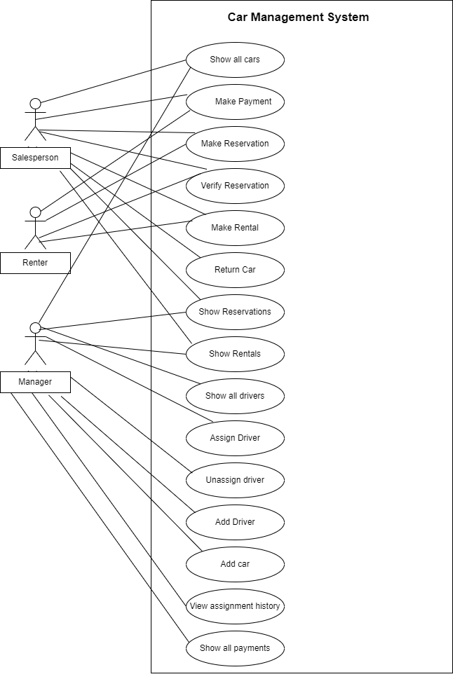

**Use Case 1: Show all cars**

Scope: System

Summary: System presents a list of all the cars according to the filter criteria of their status, which can be “All cars”, “Reserved cars”, “Available Cars”, “Unassigned Cars” or “Unavailable Cars”.

Level: User goal

Primary Actor:

1. Salesperson
2. Manager

Stakeholders and Interests:

1. Salesperson: Wants to show the renter all the cars available for rent
2. Manager: Wants to oversee all the cars in the system

Preconditions:

1. There is at least 1 car stored in the system

Success Guarantee:

1. A list of cars is shown to the salesperson/manager.

**Use Case 2: Show all drivers**

Scope: System

Summary: System presents a list of all the drivers according to filter criteria of their status, which can be “All drivers”, “Unassigned drivers”, or “Assigned drivers”.

Level: User goal

Primary Actor: Manager

Stakeholders and Interests:

1. Manager: Wants to oversee all drivers in the system

Preconditions:

1. Manager is logged in admin mode
2. There is at least 1 driver stored in the system

Success Guarantee:

1. A list of drivers is shown to the manager

**Use Case 3: Assign driver**

Scope: System

Summary: The manager pairs an unassigned car with an unassigned driver. The system updates the car status to available.

Level: User goal

Primary Actor: Manager

Stakeholders and Interests:

1. Manager: Wants to be in control of drivers that get assigned to cars.
2. Driver: Wants to work for the company and have an assigned car.
3. Renter: Wants to rent a car with an accompanying driver.
4. Salesperson: Wants to show the renter a list of all available cars for rent

Pre-conditions:

1. At least 1 unassigned driver has been added into the system.
2. A car without an unassigned driver has been recorded into the system.
3. Manager has already logged into the system.

Success guarantee:

1. A driver is assigned to a car and this information is updated in the system.
2. The newly assigned car is available for rent.

Main success scenario:

|  |  |
| --- | --- |
| Actor | System |
|  | 1)System presents manager with list of unassigned cars and unassigned drivers |
| 2)Manager selects a car and driver to pair them together |  |
|  | 3)System creates a new assignment |
|  | 4) System stores the assignment information |
|  | 5) System updates driver status to assigned |
|  | 6) System updates car status to available |

**Use Case 4: Unassign driver**

Scope: System

Summary: Manager discharges the driver from their currently assigned car and the system updates this information.

Level: User goal

Primary Actor: Manager

Stakeholders and Interests:

1. Manager: Wants to be in control of drivers that get assigned to cars.
2. Driver: Wants to be assigned to a new car.

Preconditions:

1. Driver is already assigned to a car
2. Driver is not a part of any currently on-going rental or reservation.
3. Manager must be logged in with admin mode

Success Guarantee:

1. Driver is unassigned to a car and this information is updated in the system.

Main Success Scenario:

|  |  |
| --- | --- |
| Actor | System |
|  | 1)System presents manager with list of active assignments |
| 2)Manager selects a car and a driver to un-pair |  |
|  | 3)System stores assignment ending date and updates assignment status to ‘ended’ |
|  | 4)System updates driver status to NULL |
|  | 5) System updates car status to unavailable |

**Use Case 5: Make payment**

Scope: System

Summary: Salesperson inputs the details given by the renter to create a rental, and the system calculates the total fee. Renter pays the salesperson and receives a receipt.

Level: User goal

Primary Actor:

1. Salesperson
2. Renter

Stakeholders and Interests:

1. Manager: Wants to collect payment from rentals.
2. Renter: Wants quick and error-free service with minimal effort. Wants a proof of their payment.
3. Salesperson: Wants to collect payment from renters to begin rentals.

Preconditions:

1. Renter has cash amount ready for payment.
2. Rental has been made

Success Guarantee:

1. Payment is received and record is updated in the system.
2. Receipt is generated
3. Rental period starts

Main Success Scenario:

|  |  |
| --- | --- |
| Actor | System |
|  | 1) System calculates total fee for the rent and presents it |
|  | 2) System creates a new payment |
| 3)Renter pays the salesperson, and the salesperson enters the amount into the system |  |
|  | 4) System records and stores the transaction |
|  | 5)System generates a receipt |
| 6)Renter leaves with the receipt |  |

**Use Case 6: Make Reservation**

Scope: System

Level: User goal

Summary: Renter wants to reserve a car for future use. Renter is given a reservation ID.

Primary Actors:

1. Salesperson
2. Renter

Stakeholders and Interests:

1. Manager: Wants business operations to be performed quickly and efficiently.
2. Renter: Wants to reserve a car for future rental. Wants a proof of their reservation.
3. Salesperson: Wants to assist renters in making reservations.

Preconditions:

1. At least 1 car is assigned a driver and is available for rent

Success Guarantee:

1. Reservation is recorded the and car is made unavailable to other renters.

Main Success Scenario:

|  |  |
| --- | --- |
| Actor | System |
| 1)Renter gives personal and reservation details(car license, personal contact number, rental period) to the salesperson |  |
| 2)Salesperson inputs details provided by renter into the system |  |
|  | 3)System creates new reservation |
|  | 4)System generates a new reservation ID |
|  | 5)System updates car status to reserved |
|  | 6)System calculates the total rent fee |
|  | 7)System presents a slip with reservation ID, reservation dates, renter contact and total fee |
|  | 8)System saves the reservation |
| 9)Renter leaves with reservation slip |  |

**Use Case 7: Verify Reservation**

Scope: System

Summary: Renter claims the reservation with a reservation ID and verifies their ownership of the reservation. The system allows the renter to rent their reserved car.

Level: User goal

Primary Actor:

1. Salesperson
2. Renter

Stakeholders and Interests:

1. Manager: Wants business operations to be performed quickly and efficiently.
2. Renter: Wants to avail the reserved car and begin rental.
3. Salesperson: Wants to verify reservation for the renter.

Preconditions:

1. Renter has a valid reservation ID.
2. Renter shows up on the correct reservation date.

Success Guarantee:

1. Car status is unlocked for use.
2. Car reservation is claimed.

Main Success Scenario:

|  |  |
| --- | --- |
| Actor | System |
| 1)Renter gives the reservation ID to the  Salesperson |  |
| 2)Salesperson inputs the reservation ID into the system |  |
|  | 3)System looks up the reservation ID and sends a verification code to the renter contact number |
| 4)Renter tells the salesperson the code |  |
| 5)Salesperson enters the code into the system |  |
|  | 6)System verifies the code |
|  | 7)System updates the reservation status |
|  | 8)System sends verification success message |

Alternatives:

a)Reservation ID lost

1)Salesperson asks the renter for their contact number

2)Salesperson pulls up a list of all the reservations and manually compares the contact . numbers with the provided number

3)If contact number matches, the salesperson manually enters the reservation ID to claim reservation

b)Renter cancels the reservation

1)Salesperson enters the reservation ID

2)Salesperson cancels the found reservation

3)System cancels the reservation

U**se Case 8: Make Rental**

Scope: System

Summary: A walk-in car rental is made for the renter.

Level: User goal

Primary Actor:

1. Salesperson
2. Renter

Stakeholders and Interests:

1. Manager: Wants to ensure that car rentals are made smoothly.
2. Renter: Wants to rent a car.
3. Salesperson: Wants to help the renter rent a car.
4. Driver: Wants to provide driving services to the renter.

Preconditions:

1. A car should be available for rent.

Success Guarantee:

1. Car rental is initiated.

Main Success Scenario:

|  |  |
| --- | --- |
| Actor | System |
| 1)Salesperson enters renter contact number, rental start date and end date, and car registration into the system |  |
|  | 2) System creates new rental |
|  | 3)System updates car status |
|  | 4)System sets rental status to active |
|  | 5)System saves rental record |
|  | 6)System creates new payment |
| 7)Renter makes payment |  |

Alternatives:

a) Rental is made from reservation instead of walk in

1. The reservation is verified first
2. Instead of manually entering rental information, the system automatically enters information from the reservation data to start the rental.

**Use Case 9: Return Car**

Scope: System

Summary: The car is brought back to the store by the driver on the end date of the rental. The car and rental status is updated in the system.

Level: User goal

Primary Actor:

1. Salesperson

Stakeholders and Interests:

1. Manager: Wants a record of all rentals in the system. Also wants the status of all cars and rentals to be updated according to business operations.
2. Salesperson: Wants to ensure that cars returning to the store are updated in the system.

Preconditions:

1. Car is returned to the store on the correct end date of the rental.

Success Guarantee:

1. Car status is updated in the system.
2. Rental status is updated in the system.

Main Success Scenario:

|  |  |
| --- | --- |
| Actor | System |
| 1. Driver returns car to the store |  |
| 1. Salesperson enters car registration into the system |  |
|  | 3)System looks up the rental from the car registration |
|  | 4) System updates the rental status to closed |
|  | 5) System updates the car status |

**Use Case 10: Add driver**

Scope: System

Summary: Manager adds a driver to the driver roster.

Level: User goal

Primary Actor: Manager

Stakeholders and Interests:

1. Manager: Wants to add drivers to the rental store so that they can be assigned to a car.
2. Driver: Wants to be a part of the rental store system so they can be assigned a car to drive.

Preconditions:

1. Manager is logged in to the system.
2. Driver has already been evaluated for hire by the manager.
3. Driver has a valid license.

Success Guarantee:

1. A new driver is added to the system.

Main Success Scenario:

|  |  |
| --- | --- |
| Actor | System |
| 1) Manager inputs the details of the driver into the system (hire date, name, contact, address CNIC, gender and license) |  |
|  | 2) System creates a new driver account in the driver roster |
|  | 3)System saves the details of the driver and finishes creating the new account |

**Use Case 11: Add Car**

Scope: System

Summary: Manager adds a new car to the store parking.

Level: User goal

Primary Actor: Manager

Stakeholders and Interests:

1. Manager: Wants to be able to add new cars to the system.
2. Renter: Wants to have a car to rent.
3. Driver: Wants to be assigned a car to drive.

Preconditions:

1. Manager is logged into the system.

Success Guarantee:

1. A new car is added to the system

Main Success Scenario:

|  |  |
| --- | --- |
| Actor | System |
| 1) Manager inputs all the details of the car into the system (purchase date, registration number, model, make, year, type) |  |
|  | 2) System creates a new car entry in the parking |
|  | 3)System saves the car details |

**Use Case 12: Show Reservations**

Scope: System

Summary: System displays a screen with filters named “All Reservations”, “Current Reservations”, and “Closed Reservations”. Salesperson selects the desired option and a system presents to the salesperson according to the option chosen.

Level: User goal

Primary Actor:

1. Salesperson
2. Manager

Stakeholders and Interests:

1. Manager: Wants to oversee all reservations to ensure smooth operations and to view business history.
2. Salesperson: Wants to view all reservations to assist renters.

Preconditions:

1. There is at least 1 reservation stored in the system

Success Guarantee:

1. A history of all the reservations is shown to the user.

**Use case 13: Show Rentals**

Scope: System

Summary: System displays a screen with filters named “All Rentals”, “Current Rentals”, and “Previous Rentals”. User selects the desired option and a system presents to the salesperson according to the option chosen.

Level: User goal

Primary Actor:

1. Manager
2. Salesperson

Stakeholders and Interests:

1. Manager: Wants to oversee all the rentals to ensure smooth operations and to view business history
2. Salesperson: Wants to view all rentals to assist renters.

Preconditions:

1. There is at least 1 rental stored in the system

Success Guarantee:

1. A history of all rental information is shown to the user.

**Use Case 14: View assignment history**

Scope: System

Summary: System displays history of all driver assignments to particular cars depending on the filter criteria of “all”, “active” or “terminated”.

Level: User goal

Primary Actor: Manager

Stakeholders and Interests:

1. Manager: Wants to oversee all previous driver assignments to view business history.

Success Guarantee:

1. A history of all the driver assignments is shown to the manager.

**Use Case 15: Show all payments**

Scope: System

Summary: System presents a list of all payments to the manager.

Level: User goal

Primary Actor: Manager

Stakeholders and Interests:

1. Manager: Wants information about payments.

Preconditions:

1. There is at least 1 payment record stored in the system

Success Guarantee:

1. A list of all payments is shown to the manager